**S3 Bucket:** Every object in S3 is stored in a bucket. To upload files and folders to S3, you’ll need to create a bucket where the objects will be stored.

Buckets are containers for data stored in S3.

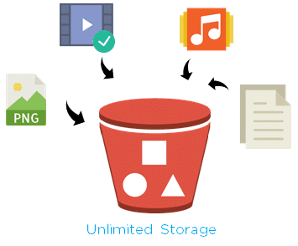

**General configuration** 🡪 AWS Region 🡪 Bucket type(General Purpose) 🡪 Bucket name

**Object Ownership** 🡪 ACLs disabled (recommended)

**Block all public access 🡪 Bucket Versioning (Enable)**

**Default encryption 🡪** Encryption type (Server-side encryption with Amazon S3 managed keys (SSE-S3)) 🡪 Bucket Key (Enable)

* Create bucket

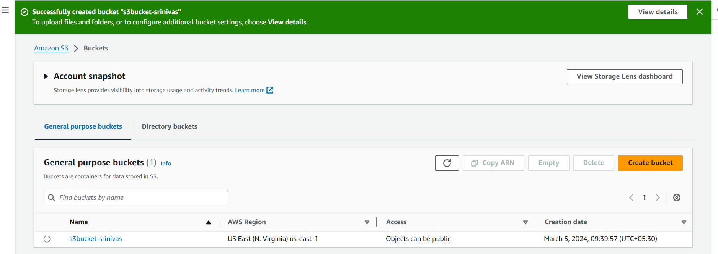

* **Upload 5 different extension files in our S3 Bucket**

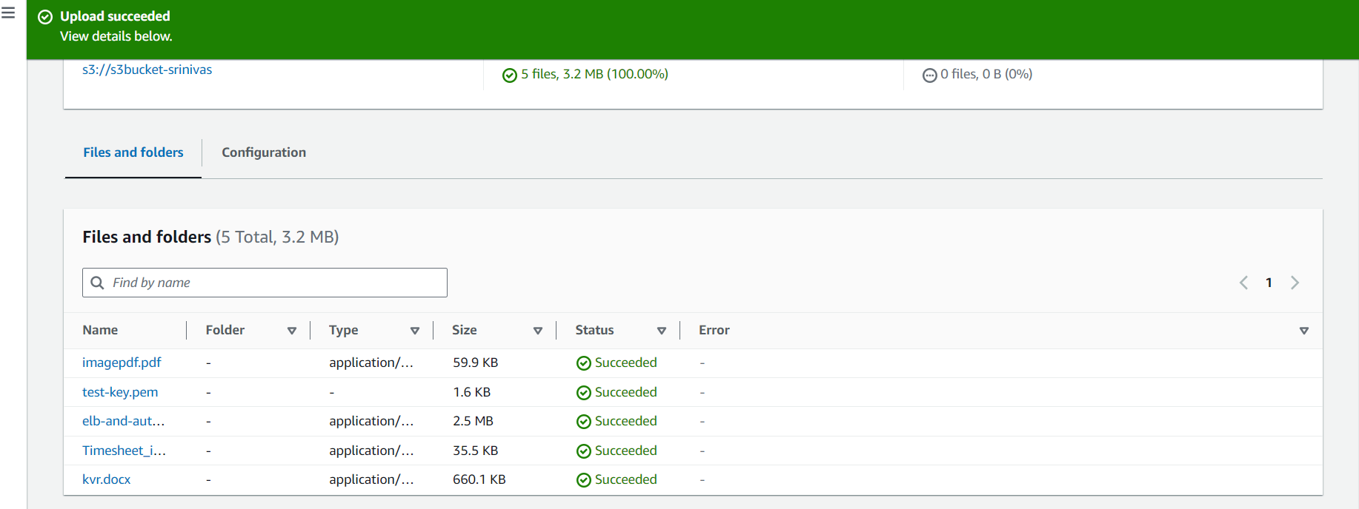

* **Bucket Versioning (Having multiple variant of same file):**
* Create s3 bucket here enable bucket versioning
* upload 2 files
* check here bucket versioning working fine or not
* go to inside properties
* edit bucket versioning
* enable and save the changes
* go to object tab enable show versioning icon

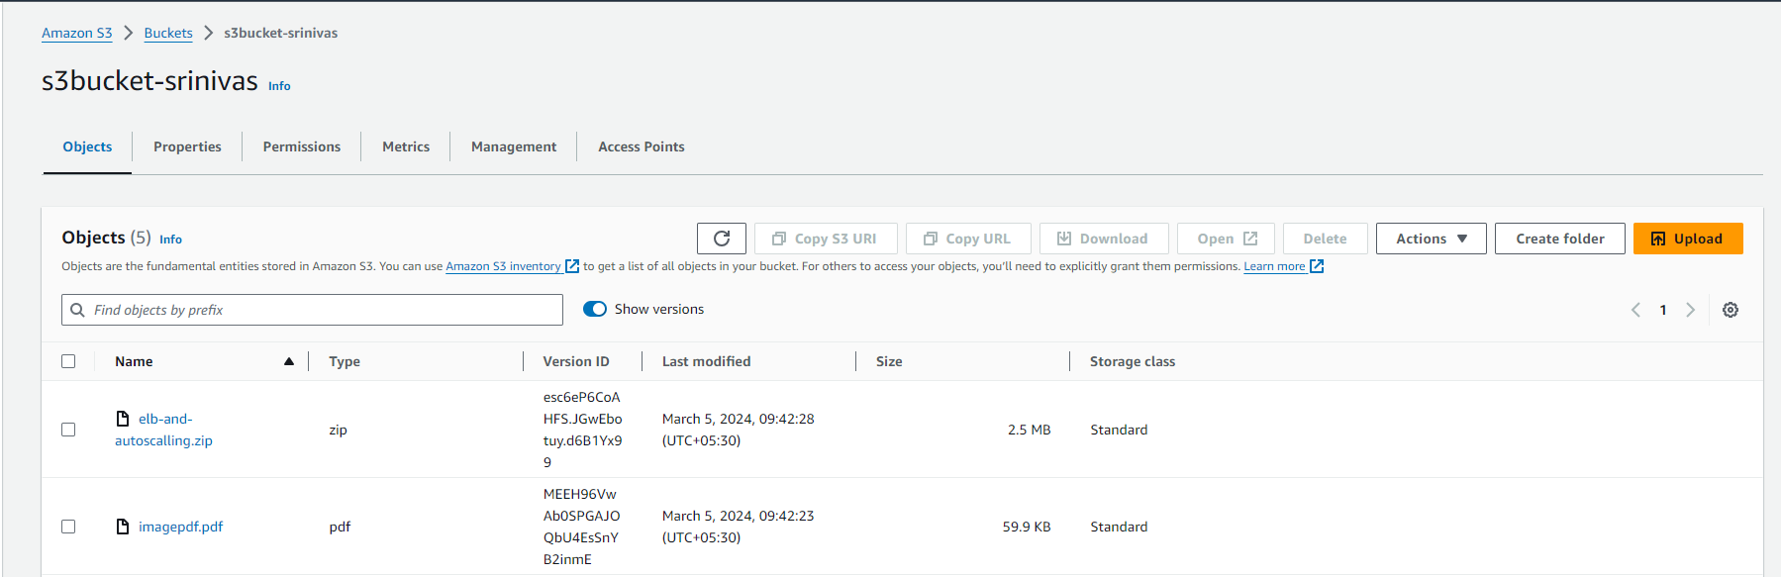

* **S3 bucket webhosting:**
* upload index.html and error.html

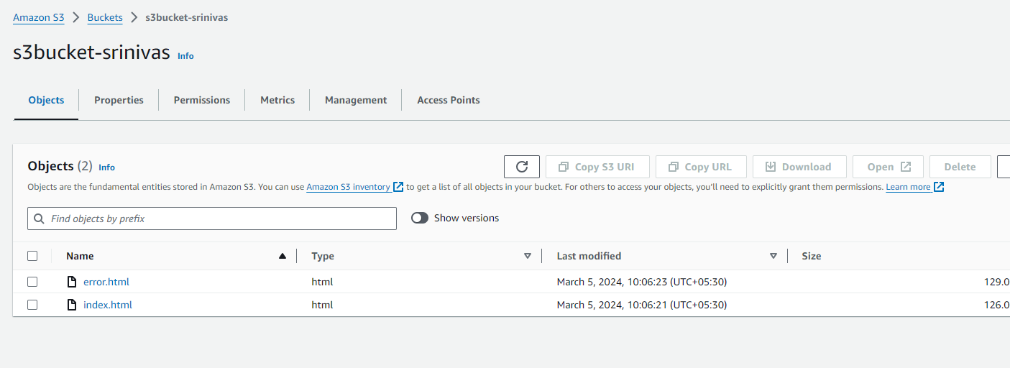

* go to properties edit static website hosting

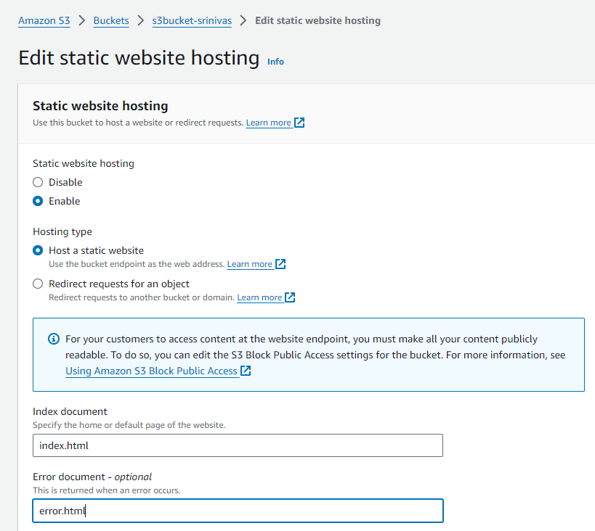

* how can you make a bucket in public 🡪 uncheck the Block all public access

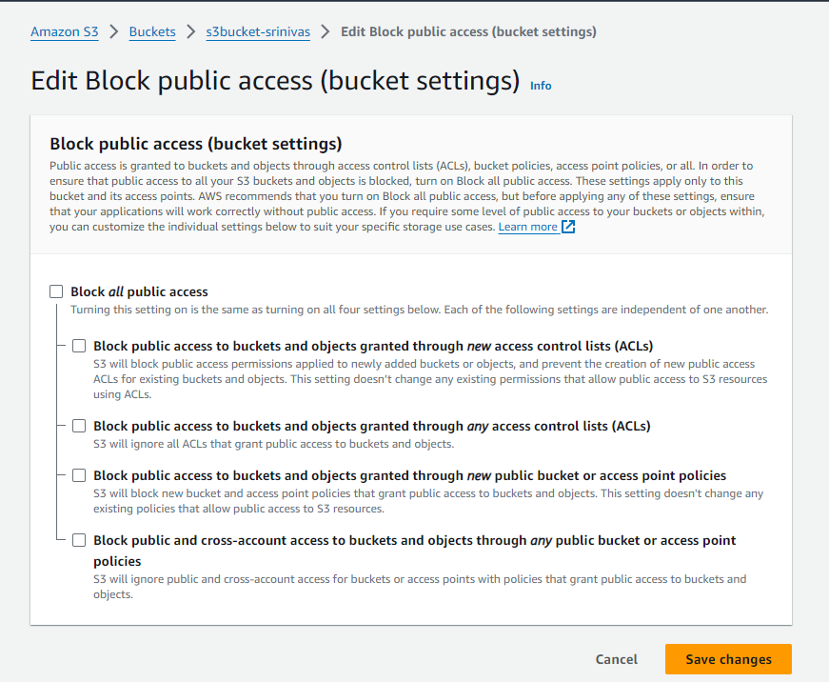

**Policy generator:**

* Go to permissions tab 🡪 Edit Bucket Policy
* Select Type of Policy: s3 bucket policy Effect: allow Principal: * Actions: Get Object Amazon Resource Name (ARN) : arnofyourbucket/* Add Statement Generate Policy

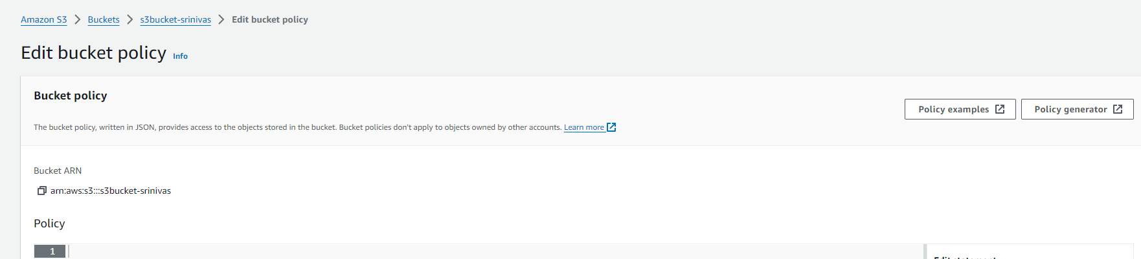

Next

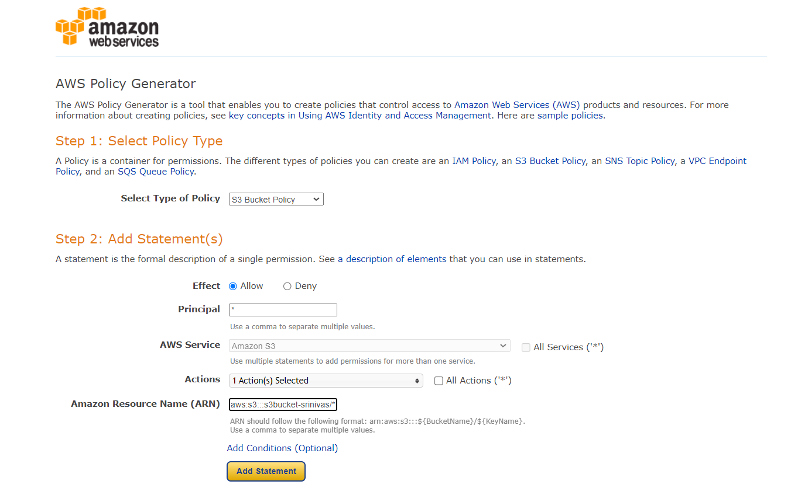

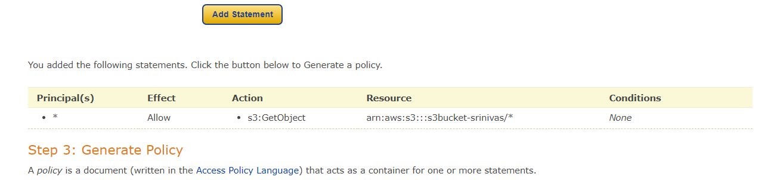

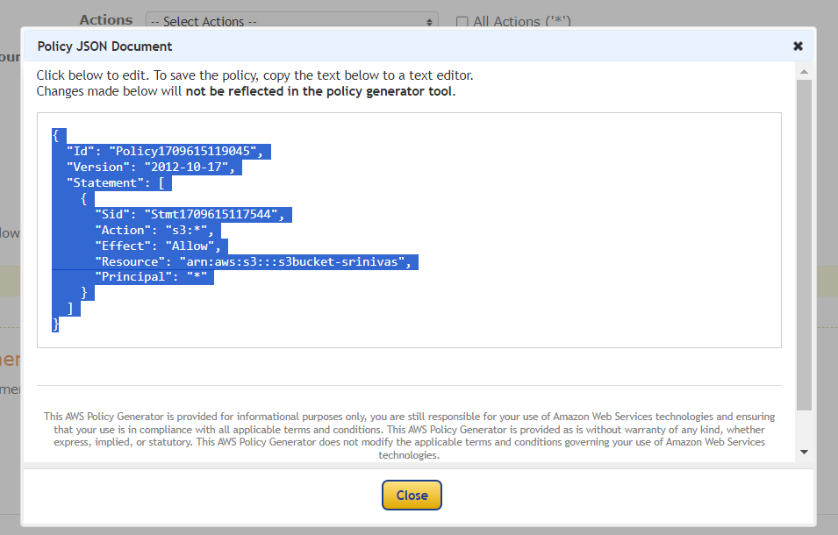

**Add lifecycle rule:**

Add a lifecycle rule for the bucket:

a. Transition from Standard to Standard-IA in 60 days

b. Expiration in 200 days

* Bucket 🡪 go to management section 🡪 Create Life Cycle rule



